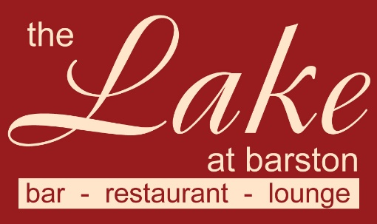

Christmas Fayre Lunch Set Menu 2022
This menu is available for parties of 2 to 200 people.
Set Menu, no pre order required (please advise Vegetarian main dishes required)
3 courses £19.95 pp (v – vegetarian, vg – vegans, gf – gluten free, cn – contains nuts)

Starters
Fresh Tomato & Vegetable Soup (v,vg,gf)
**********
Main Courses
Roast Breast of Turkey
served with Bacon wrapped Chipolata, Stuffing, Roast Potatoes, vegetables & gravy
Roasted Vegetable and Chestnut Timbale served with wild Rice (v,vg,gf)
served with new potatoes
**********
Desserts
Christmas Pudding with Brandy sauce (v)

The Lake at Barston Restaurant, Barston, Solihull, B92 0LB. 01675 444890

