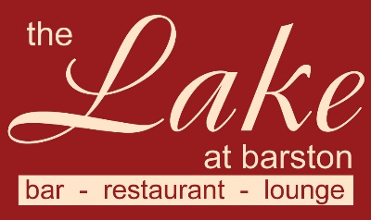
Christmas Festive Gold Menu 2022
3 courses £27.95 pp (v – vegetarian, vg – vegan, gf – gluten free, cn – contains nuts)
A pre order will be required 1 week before the event

Starters
Fresh Homemade Vegetable Soup (v,vg,gf)
Fan of Melon, with exotic fruit compote and Mango Coulis (v,vg,gf)
Button Mushrooms in a creamy Garlic & White wine sauce (v,gf)
Baked English Brie with Cranberry & Apple Compote (v)
Main Courses
Roast Breast of Turkey
served with Bacon wrapped Chipolata, Stuffing, Roast Potatoes, vegetables & gravy
Seared fillet of Salmon
served with Dill cream sauce, new potatoes & vegetables (gf)
Roasted Pork Loin
served with Bacon wrapped Chipolata, Stuffing, Roast Potatoes, vegetables & gravy (gf)
Lamb Shank
Slow roasted Shank of Lamb with Mashed Potato, Minted gravy & vegetables (gf)
Mediterranean Veg & Rice Timbale with Chestnut, Tomato & Basil Sauce (v,vg,gf)
served with new potatoes
Desserts
Christmas Pudding with Brandy sauce (v)
Toffee & Honeycomb Cheesecake (v)
Terry Chocolate Orange and Baileys Ice Cream Sundae (v,gf)
Fresh Fruit Salad (v,vg,gf) with pouring cream

The Lake at Barston, Solihull, West Midlands 01675 444890

