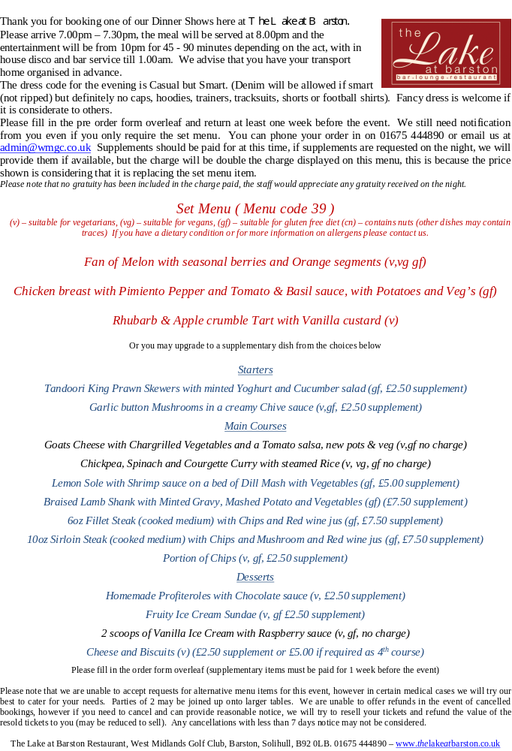

Name of Tribute ____________________ Event Date _____________ Todays date____________

Organisers Name ______________________________ No of Guests ______________________
Set Menu Dishes are in ORANGE Columns, Pink Columns are Supplementary items
 |  | STARTER |  |  | MAIN |  |  |  |  |  |  |  | DESSERT |  |  |  |  | 4th
Names |  | MELON | Prawns £2.50 | Mushroom £2.50 | CHICKEN | Goat Ches £0.00 | Vegan Curr £0.00 | Fish £5.00 | Lamb £7.50 | Fillet £7.50 | Sirloin £7.50 | Chips £2.50 | CRUMBLE | Profiteroles £2.50 | Sundae £2.50 | Ice Cream £0.00 | Cheese £2.50 | Cheese £5.00
1
2
3
4
5
6
7
8
9
10
11
12
13
14
15
16
17
18
19
20

