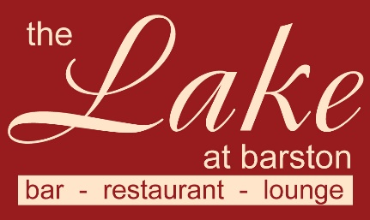

Sunday 18th September 2022
Starters £5.00, Carvery £14.95, Vegetarian/vegan main £12.95 Desserts £5.00
Under 12s £8.95, Large plate main course add £3.00,
(v –vegetarian, vg – vegan, gf – gluten free, cn - contains nuts - further allergy information available on request)

Starters

Tomato and Basil Soup (v, vg, gf)

Duo of Melon with Pineapple and Passionfruit (v, vg, gf)

Atlantic Prawn Cocktail with Marie Rose sauce (gf)

Farmhouse Pate with Ale Chutney and Ciabatta

Panko crumbed Calamari Rings with Garlic mayo

************************
Mains

Breast of Turkey, Sirloin of Beef, or Gammon,
served with potatoes, Vegetables and gravy from the carvery.

Spinach and Ricotta Cannelloni with vegetables from the carvery (v)

Malaysian Sweet Potato Curry with Rice (v, vg, gf)

Desserts

Hot Apple Pie with Custard (v, cn)

Chocolate Fudge Brownie with Chocolate sauce and Whipped Cream (v)

Lemon Meringue Ice Cream Sundae (v, gf)

Fresh Fruit Salad (v, vg, gf) with Pouring Cream (v, gf)

Vanilla Ice Cream (v, gf)

Mixed Ice Cream (v, gf)

Cheese and Biscuits (v) (£2.50 Supplement)

We kindly ask that all Children are supervised at all times, Thank you

