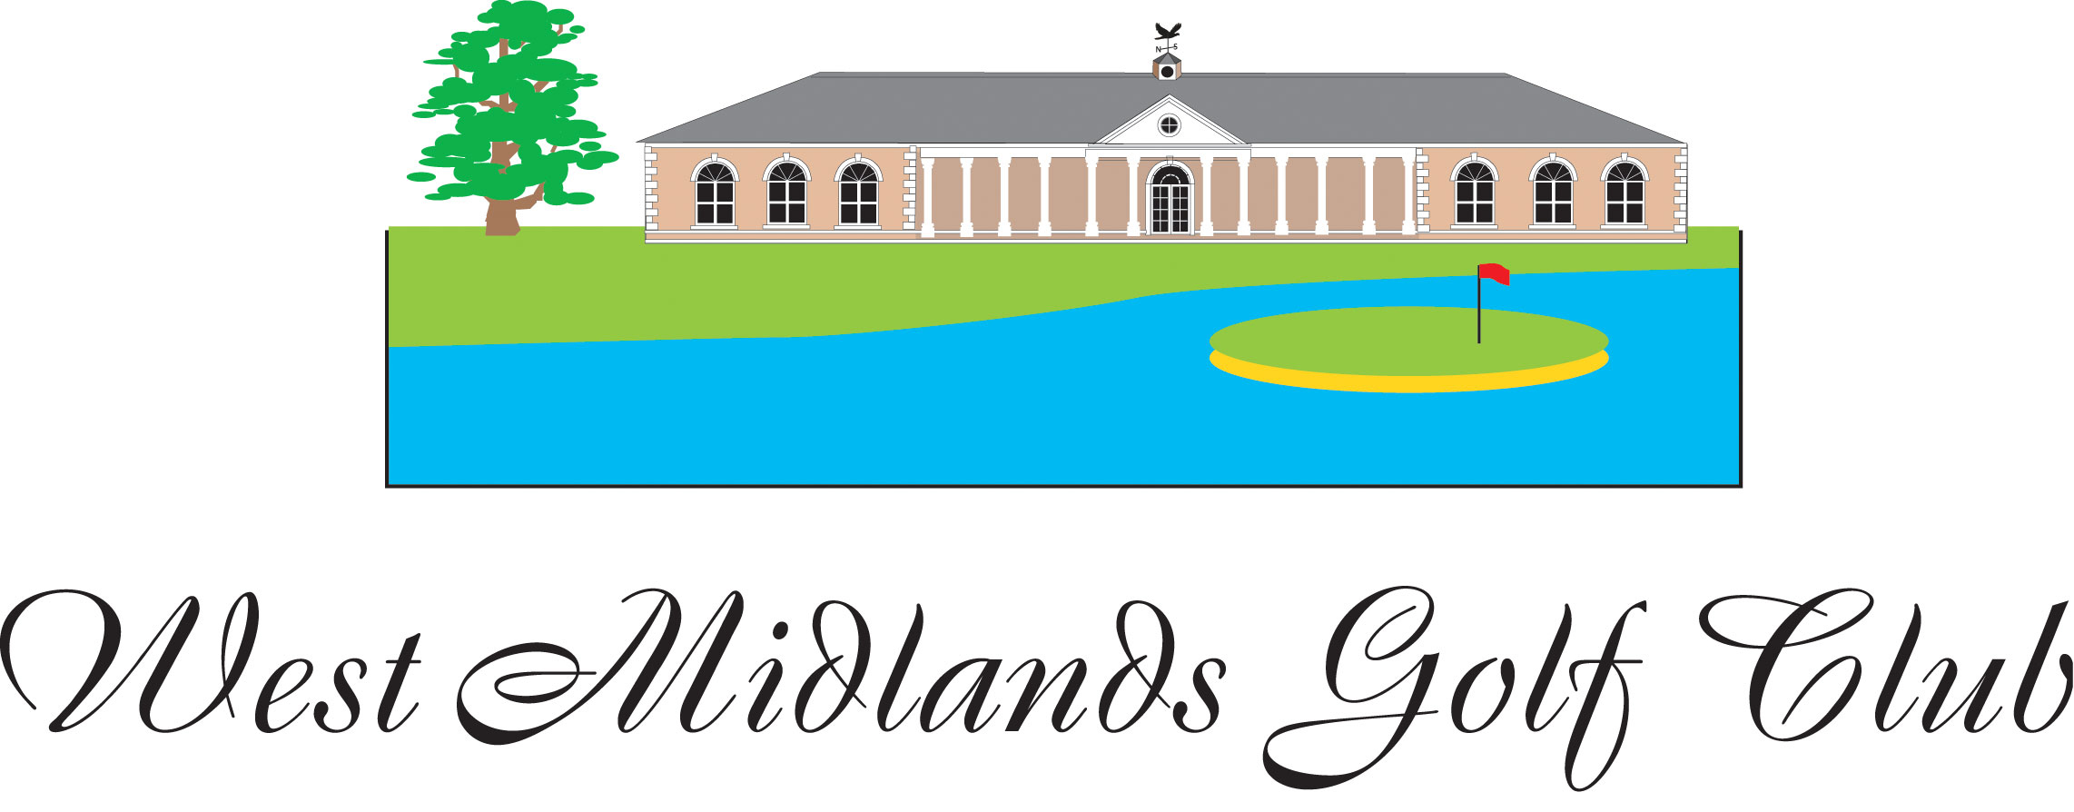

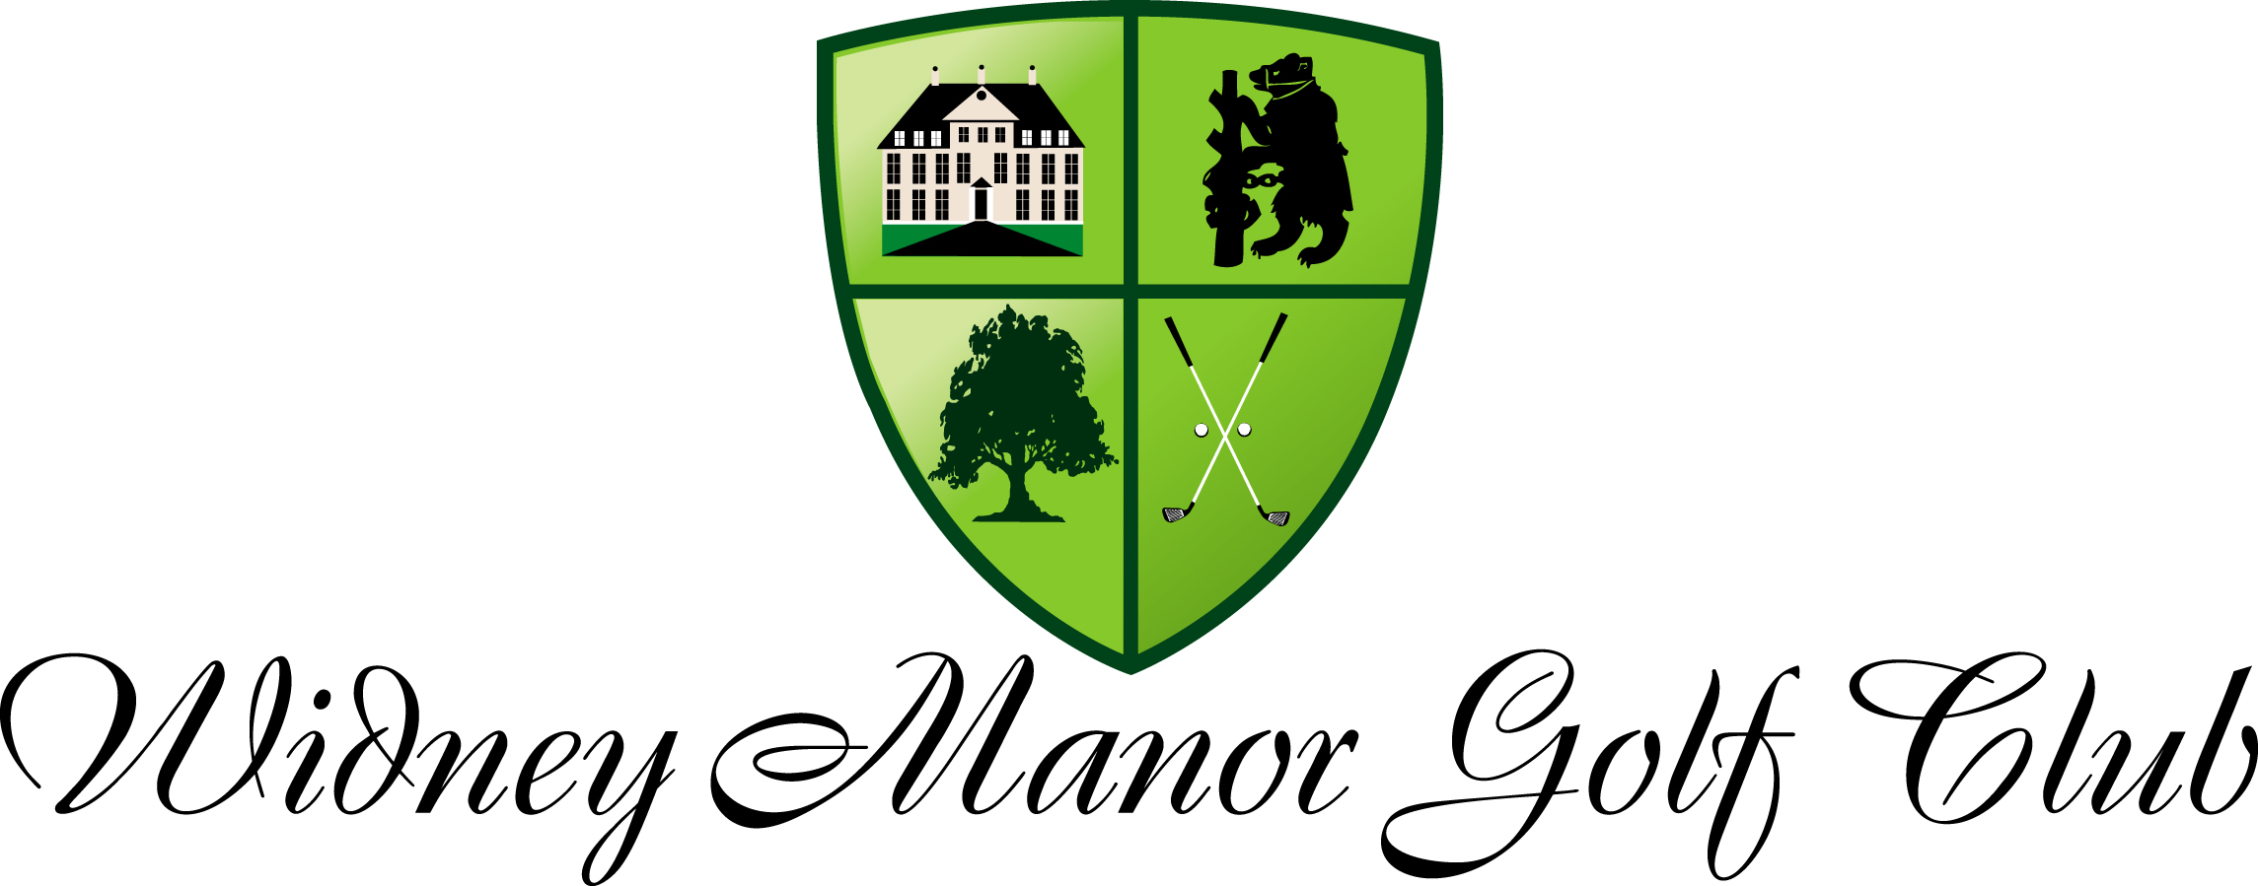

MEMBERSHIP APPLICATION FORM

Name
Address:
Postcode |  | Car reg
DOB |  | Category
Tel Number | Home | Mobile
Next of kin | Name | Mobile
E-mail
CDH No

Membership cost | Method of payment
£ | Annual renewal month, first day of

If paying by cheque please make out to West Midlands Golf Club. For credit card payments please pay in person or call us with your card number. BACS payments to Allied Irish Bank, John Harrhy & Sons Ltd No 2 account, 23-83-93, 03423044 with your name as reference

Important, please read.
By signing this agreement you are joining the golf club for a 12 month period. We accept payment of fees by direct debit (see form overleaf) and in this case you promise to make at least 12 payments. If you fail to make 12 payments, the total amount to be paid less any payments made will become due, and your contract will be passed to a debt collection agency and you may incur additional costs. After the initial 12 months, we will write to you advising you that your membership is due for renewal at which point you may notify us to cancel the agreement, otherwise we will renew the agreement for a further 12 months. You may then cancel the agreement by notifying us within the month prior to your renewal date. Any unpaid direct debits will incur an administration fee.

I agree to be bound by the rules of the golf club if admitted as a member. Please note, application and payment does not guarantee acceptance. The club reserve the right to return your application without providing reasons for non-acceptance.

Signature |  | Date

All administration for West Midlands & Widney Manor Golf Clubs is conducted from the head office at;
West Midlands Golf Club, Barston, Solihull, West Midlands, B92 0LB. 01675 444890

Staff use
Payment processed
Member no / entitlement
Photograph taken
Club V1 record
Welcome email
Web registration
Direct Debit set up

