1. Backstitch
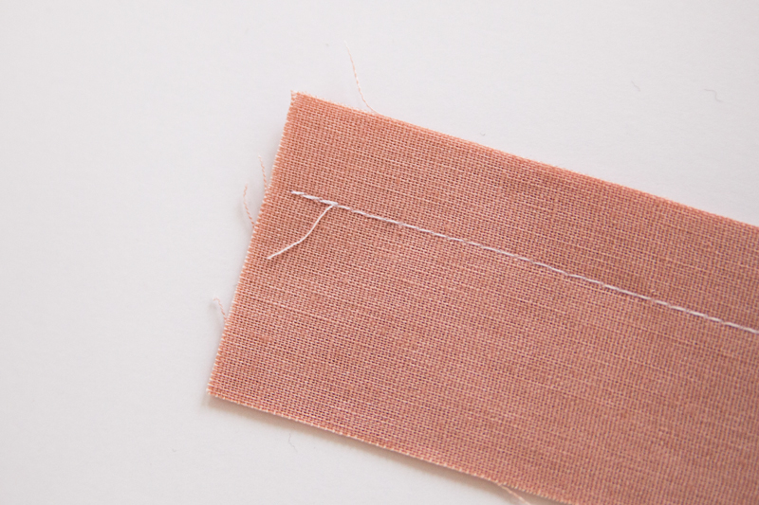
A backstitch is necessary to secure a line of stitches. Backstitching is overlapping stitches at both the beginning and end of a stitching line. This is done by sewing approx. 1-3 stitches by machine, reversing the direction of the feed dogs and stitching directly on top of the previously-made stitches. After backstitching, continue sewing the rest of the seam, and repeat the backstitching process at the end of the stitching line.

2. Baste
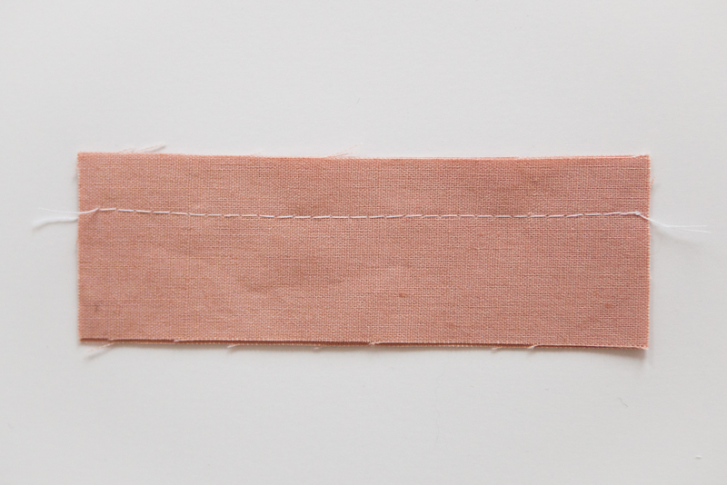
Basting stitches are long stitches done by hand or machine that temporarily hold fabric in place before sewing. They are removed once the final seam is in place.

3. Clip
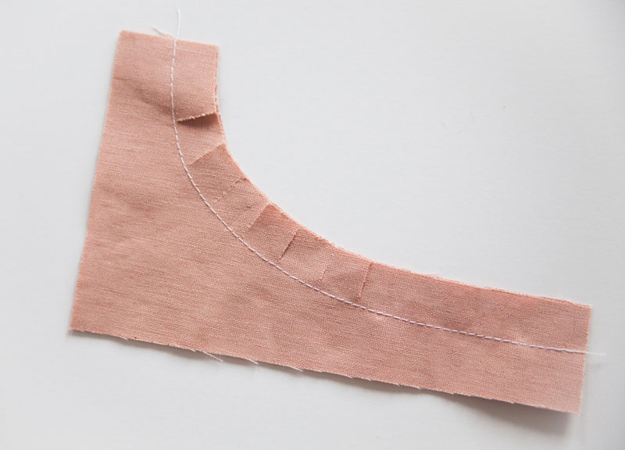
To help flatten a curved seam, snip at even intervals along the inner curve, being careful not to cut into the stitch line.

4. Edgestitch
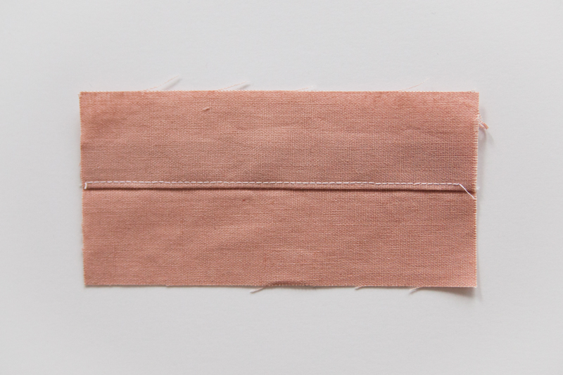
To edgestitch, add a second row of stitches very close to the seam line on the right side of the fabric. This is usually sewn to keep pressed seams in place.

5. Finish seams
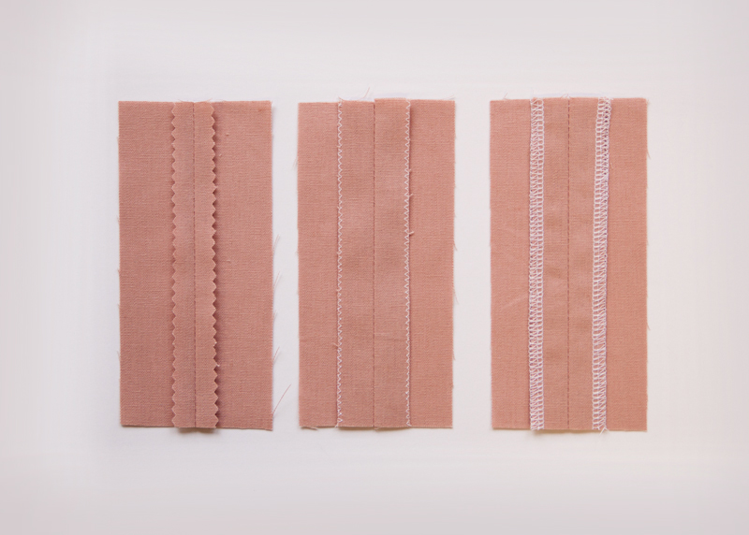
There are many ways to finish a seam or raw edge to get a neat look and prevent fraying. For sturdy fabrics, just trim seams with pinking shears. For lighter fabrics, use a zigzag stitch along the seam. Other methods of finishing include turned-under seams, bound edges, and serged edges. Learn six different techniques for finishing seams, here.

6. Gather
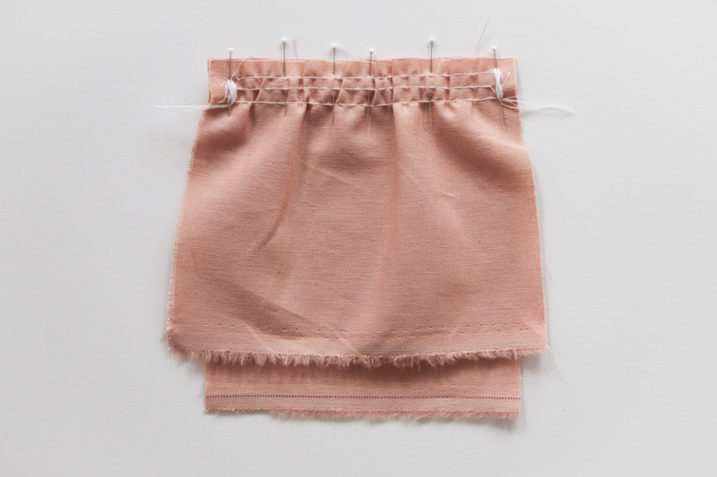
Gathering stitches are used to sew a longer edge to a shorter edge, resulting in significant fullness. Use a long stitch length and stitch three rows parallel to each other. Leave long thread tails which can be tugged to adjust ease before you sew. See our gathering tutorial, here.

7. Grade seam
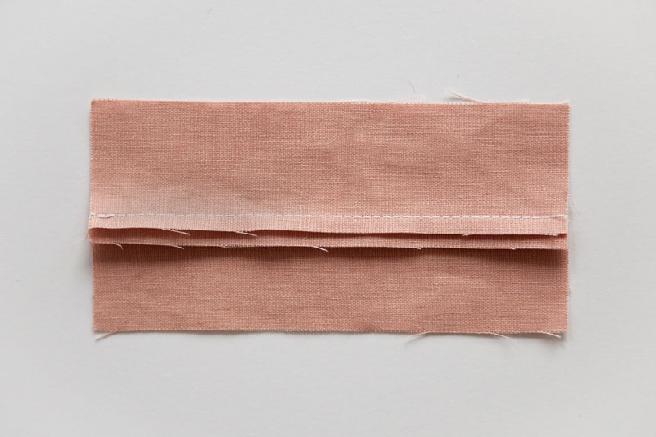
Seams need to be graded to reduce bulk when pressing the seam allowance in a single direction. After the seam is sewn, trim the seam allowance in half. Then, identify which side of the seam allowance will be laying against the body once it is pressed, and trim that side of the seam allowance in half.

8. Knit Fabric
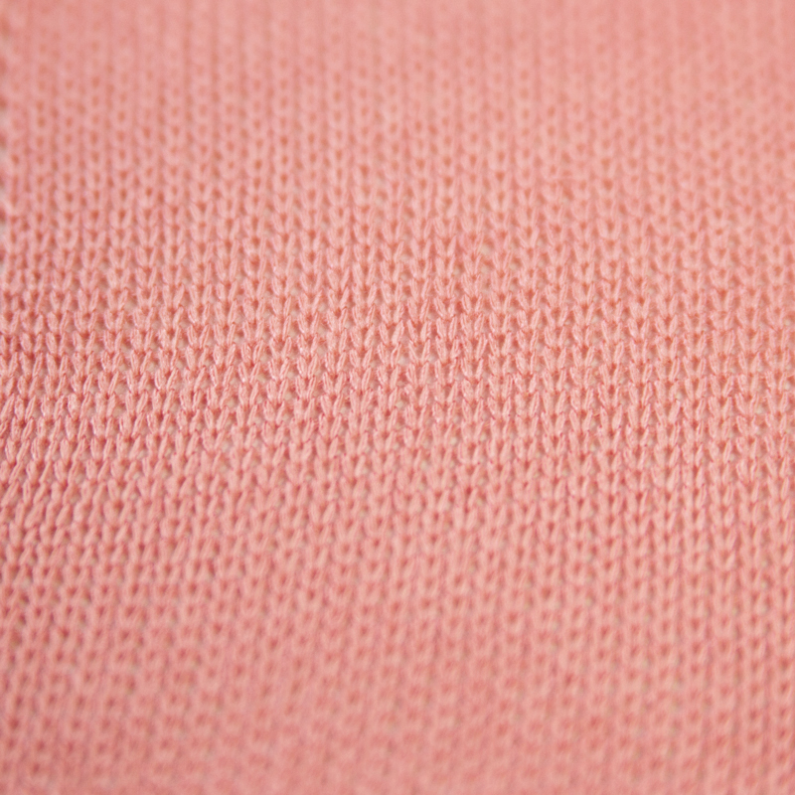
Knit fabric is created from one continuous piece of yarn that is looped repeatedly. This looped structure gives knit fabrics a great deal of stretch. Knit fabrics will unravel but will not fray. Learn more about knit fabrics, here.

9. Woven Fabric
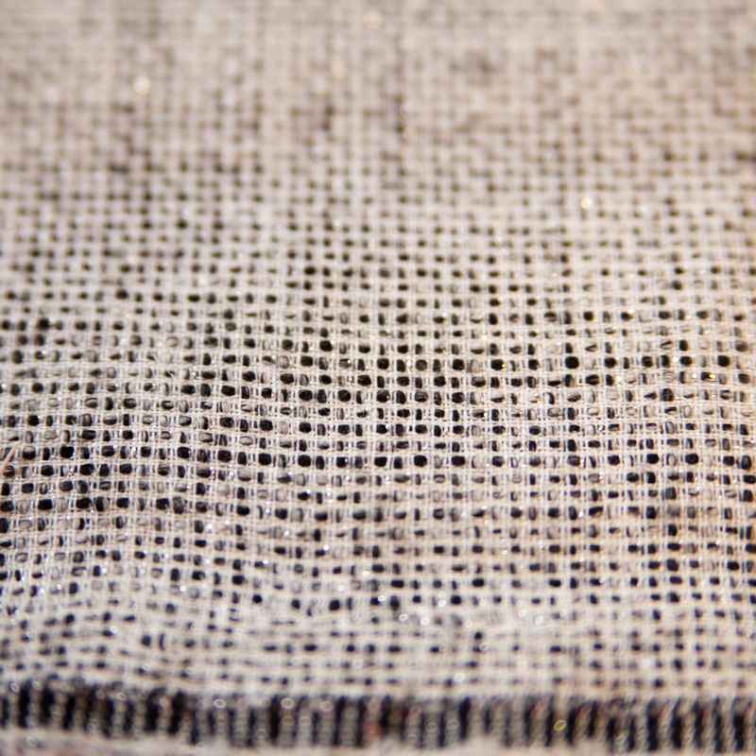
Woven fabric is created by weaving multiple yarns across each other at right angles. These fabrics usually have no stretch along the lengthwise, little along the crossgrain, and the most stretch along the bias. Depending on the fiber content, some woven fabrics will have more stretch than others. Woven fabrics will unravel and raw edges should be finished.

10. Notch
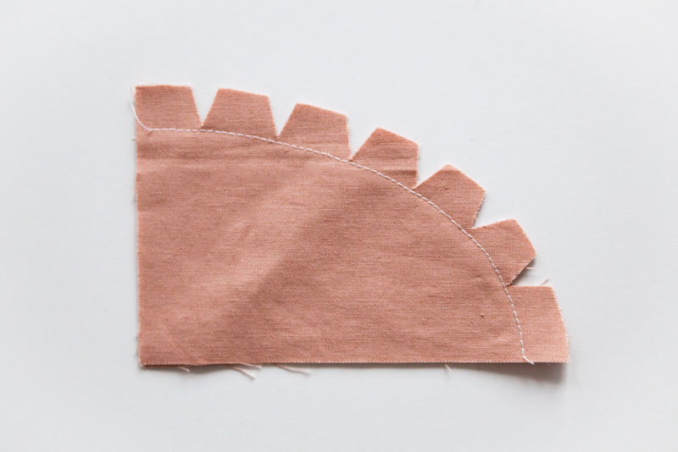
The notches on a pattern help align the pattern pieces when you sew them together. Another type of notch is one that is added when sewing the outside edge of a curved seam. These notches are added by cutting wedge shapes into the seam allowance at even intervals, being careful not to cut into the stitching.

11. Raw edge
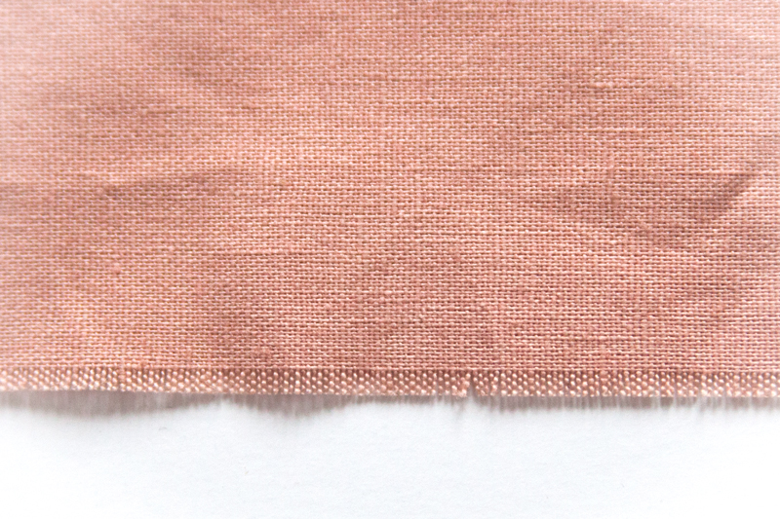
The raw edge is the unfinished, cut edge of the fabric.

12. Right side & wrong side
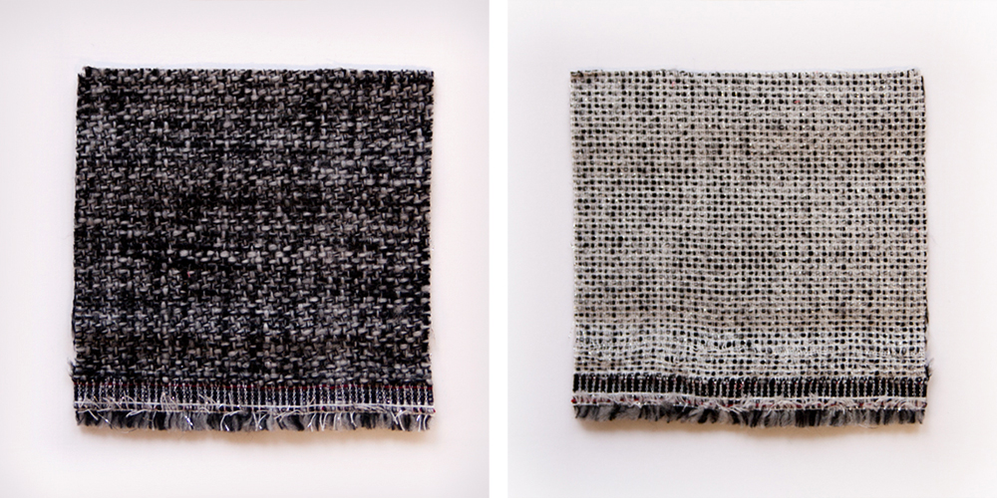
The right side of the fabric will show on a finished garment; the wrong side will be on the inside. Here’s a quick tip: the raw edges of knits fabrics tend to roll toward the right side.

13. Staystitch
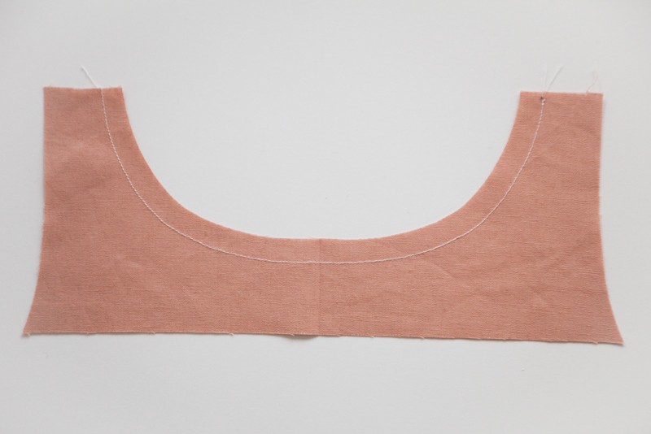
Staystitching is a straight stitch sewn through one layer of fabric. It’s most often used around a curve to prevent distortion, as it stabilizes a piece of fabric before it is sewn. This stitch is traditionally at a slightly smaller stitch length. Learn more about the the importance of staystitching, here.

14. Seam Allowance
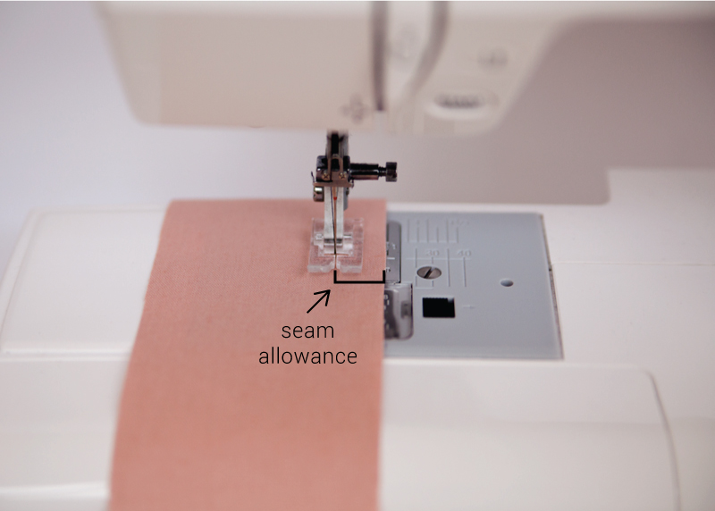
The seam allowance is the distance between the stitching line and the raw edge of a piece of fabric. Most commercial patterns have a 5/8″ seam allowance.

15. Stitch length
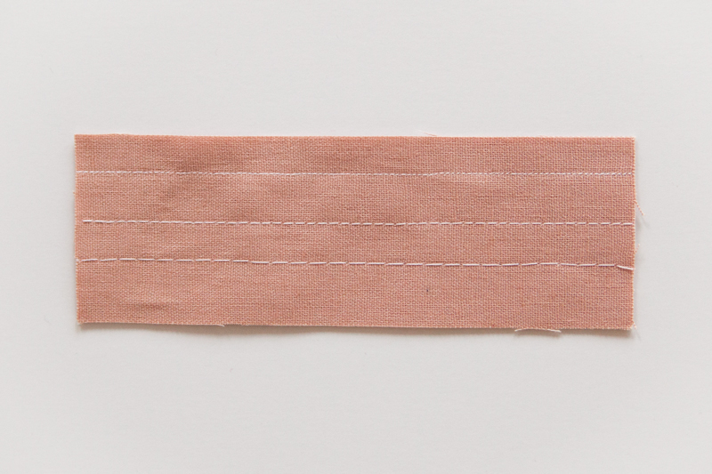
The stitch length is determined by the movement of the feed dogs. It can be set so that the stitches are longer or shorter, depending on the project.

16. Topstitch
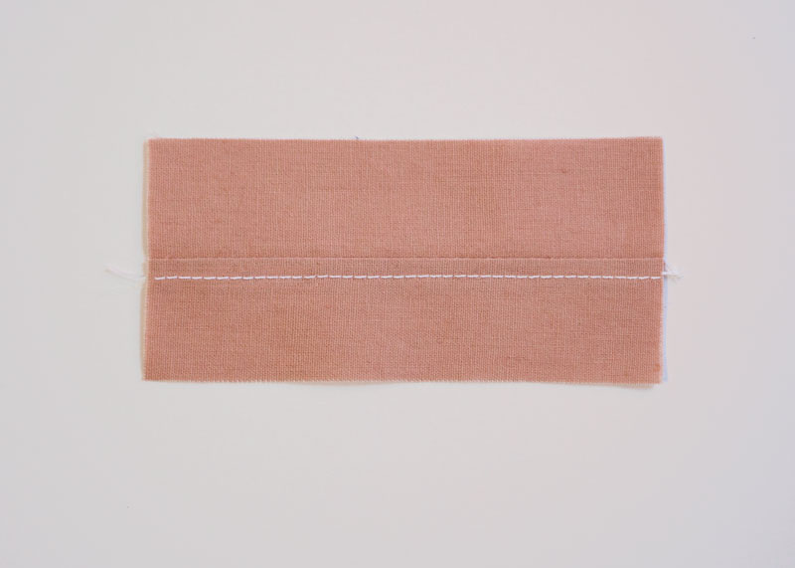
Topstitching is stitching on the outside of a garment that is parallel to, and usually 1/4″ from the seam. To topstitch, sew through the fabric and seam allowance after pressing to help the seam lay flat. Topstitching is similar to edge stitching, but more noticeable, and can be used decoratively.

17. Understitch
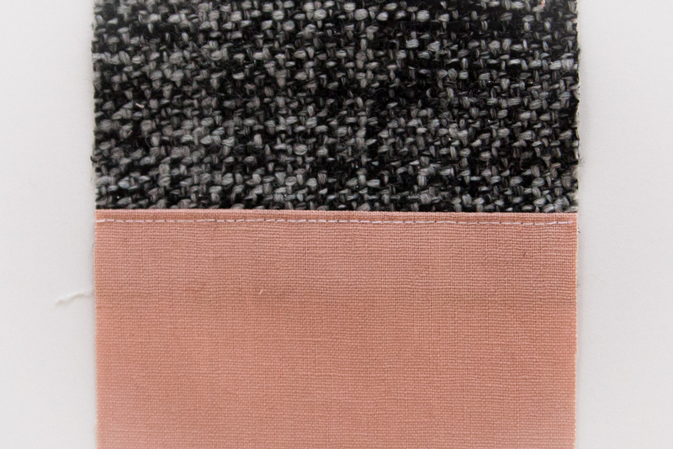
Understitching is stitching that helps seams lay flat and prevents facings and linings from rolling to the outside of the garment. Press the seam toward your facing, then stitch the facing to the seam, very close to the seam line. See our understitching tutorial, here.
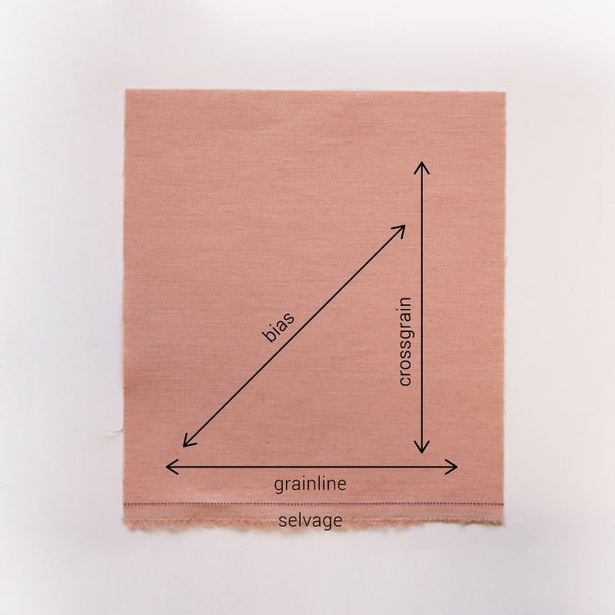

18. Bias
True bias is a cut made on an angle, 45 degrees to the selvage. This direction allows for the most stretch. Bias refers to any line diagonal to the crosswise and lengthwise grains. Most bias pattern pieces are laid on the true bias; the grainline arrow and the pattern’s layout instructions will help you align your pattern pieces.

19. Selvage
Selvage is the self-finished edge of fabric. The selvages are located on either finished edge of fabric and are made while the fabric is being manufactured, usually on a loom.

20. Grainline
The grainline runs parallel to the selvage. The long arrow symbol printed on a pattern corresponds to the location of the fabric’s grainline when laying out patterns.

21. Crossgrain
The cross grain runs perpendicular to the selvage.

